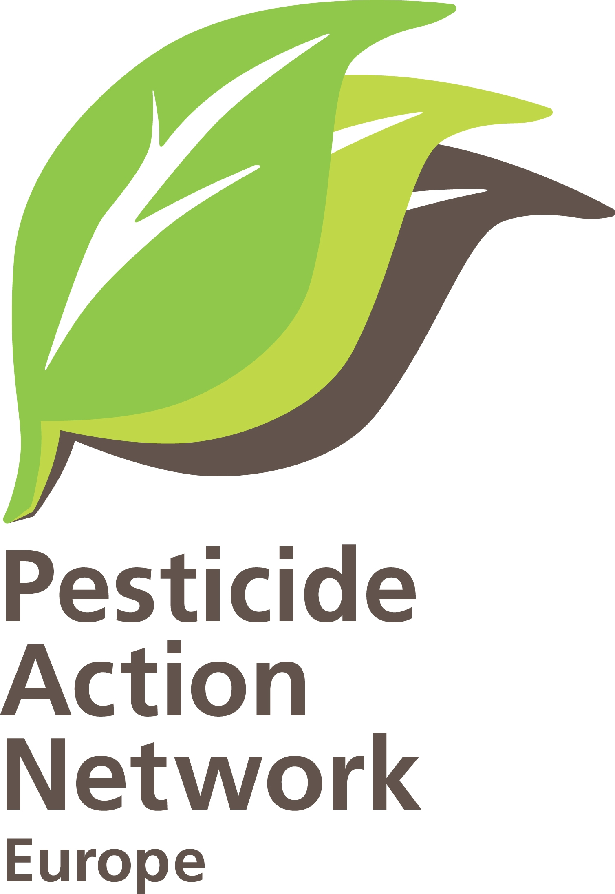 | Briefing:  Integrated Production and  Integrated Pest Management  ’an agro-ecological approach to pest management and action to reduce dependence on harmful pesticides by means of strong IPM programmes’  The 2008 UN International Assessment of Agricultural Knowledge Science & Technology for Development (IAASTD) report, endorsed by many EU countries
December 2010

Integrated Production: an opportunity for European farming
It is the right moment to promote implementation of Integrated Production in European farming to encourage more sustainable agricultural practices which protect the environment and human health and conserve biodiversity while at the same time help to ensure food security in the longer run. This briefing looks at the policy opportunities for IP.

What is Integrated Production?
Integrated Production (IP) is a knowledge-based approach to farming, based on maximising natural control processes for pest and soil management and growing a healthy crop. It is a dynamic approach to move towards sustainable farming systems, introduced in steps up the IP ‘ladder’.

The International Organisation for Biological Control (IOBC) has pioneered the development of IP in Europe and publishes IP guidelines for a range of cropping systems (see http://www.iobc-wprs.org/ip_ipm/index.html).

In terms of managing pests, diseases and weeds, at the heart of IP lies application of agronomic techniques aimed at preventing these from building up to levels that cause economic damage to the crop. When prevention methods alone are insufficient, IP farmers give preference to non-chemical alternatives, such as biological control of insect pests, physical trapping, mechanical weeding. IP farmers only use synthetic pesticides as a last resort and take care to select the least toxic products and to target and apply these in ways that minimise exposure of non-target wildlife and contamination.

How an IP strategy for potatoes might be applied:
1. Create wide crop rotation and aim to grow potatoes only once every four years
2. Use only potato varieties resistant to late blight disease
3. To further prevent late blight use plant strengtheners like basalt or sulphur
4. Another way to discourage late blight is to plant crops further apart
5. To treat late blight use a decision-supporting system to minimise treatment
6. Only treat Rhizoctonia disease on the basis of analysis (exceeds damage threshold)
7. Apply fertilisers prudently in the season and only along potato rows
8. Be tolerant of weeds and only use only mechanical weeding
9. Dedicate 5% of field area to biodiversity by not planting crops or applying chemicals
10.Only use chemicals as a last resort and only those which do not harm beneficial organisms

By integrating appropriate crop husbandry, non-chemical methods and careful decision-making, the need for pesticide use can be greatly reduced under effective IP systems.

To reduce reliance on pesticides, IP farmers need a good understanding of ecological processes that affect pests and their natural enemies, along with regular monitoring of their fields and access to early warning systems, which help decision-making on choice and timing of pest management interventions. Farmer group learning activities and technical support from independent advisors assist farmers to climb up the IP ladder, building new components into their farming system and gaining experience and confidence.

The stepwise approach to be implemented in the EU
Directive 2009/128/EC on sustainable use of pesticides (SUD) makes it mandatory for each farmer in the EU to implement Integrated Pest Management as from 2014 and they will also be encouraged to apply Integrated Crop Management (ICM, covering fertilizers and other agrochemicals).
This means first of all that Member States need to ensure that farmers have at their disposal information and tools for pest monitoring, decision making, training and advisory services on pest management (article 14.2).
It also means that each farmer as from 2014 needs to take preventive actions at the farm level to avoid damaging levels of pests, diseases and weeds, via use of appropriate agricultural practices such as crop rotations, cultivation techniques, sowing date and density, etc. (annex 3). This means the EU agricultural policy reflection on which Common Agricultural Policy towards 2020 must take IPM and ICM elements into account.

A solid support system needed at national level
Member States should make sure that each farmer as from 2014, if possible earlier, has access to independent advisory services assisting in getting an annual farm IP plan designed, informing about preventive actions, damaging levels of pests, diseases and weeds, via use of appropriate agricultural practices such as crop rotations, cultivation techniques, sowing date and density, inform about available non-chemical alternatives, but also about the benefits of pastoral grassland, smaller field size or, even better, wider field margins, reestablishment of hedgerows, etc.

It is important to establish a dynamic system led by ‘front-runners’ who are willing to make the necessary changes and share their experiences with others. Also it is important to encourage the step-by-step introduction of environmental and health improvements, with agro-ecological farming at the top of the ladder.

IPM to be implemented by all farmers in the EU as from 2014
According to the framework directive on sustainable use of pesticides, as of 2014 all EU farmers must apply Integrated Pest Management at the farm level.
However, there are many steps on the IP ‘ladder’, which depend on what crops are being grown and each farm’s particular circumstances, so it is impossible to set out a detailed ‘prescription’. The best way forward for EU-level policy is:

Defining what is not IPM: IPM is a dynamic approach, with different views about the baseline, where the definition of IPM starts and what practices cannot be considered as IPM. In PAN Europe’s view, IPM principles are contradicted by practices which rely on: continued monoculture; soil fumigation; broad spectrum pesticides (which harm non-target organisms); ‘calendar’ spraying, without assessment of need; use of GM crops. So these practices are not to be considered IPM, and should be excluded from receiving public funding as from 2014 (can be done by adding a column ‘banned practices’ in Good Agricultural and Environmental Conditions).

Define the basic level of IPM: By 2014 each farmer must apply pest preventive agricultural practices. Though, as IPM means a holistic approach to farming, farmers should be requested to apply a package of practices to prevent pest build-up, covering not only sustainable practices within fields but also establishment of buffer strips along water courses, buffer strips between fields, smaller plots (ecological set aside). Within the field, arable crop growers should apply mandatory crop rotation in a systematic (perennial) approach, and fruit and vegetables growers introduce cover crops, permanent pasture etc. Another element worth investigating further is conservation tillage.

Under the mandatory element to apply IPM, farmers also should be asked to develop pest management plans, and need to record their use of pesticides, including a valid justification for each application. Use recording will be an essential element to obtain more data allowing the EU to develop indicators in the future.

Defining Integrated Crop Management (ICM): As from 2014 there will be policy support for farmers to apply ICM on a voluntary basis. ICM means taking a broader approach to growing crops, including fertiliser use and managing soil, water and field boundary vegetation, which can all affect pest levels and crop health. Member States must upgrade their potential IPM programmes, offering specific support to farmers wishing to introduce sustainable agronomic practices beyond the mandatory requirement. Rural Development programmes, should also, at least temporarily, support farmers if they incur increased costs for purchase of non-chemical alternatives or in adjusting their farmland management to encourage natural pest control.

PAN Europe recognizes that many farmers are reluctant to swap short-term certainty for longer-term sustainability. It is hard to undertake a change when being part of a chemical-dependent system and part of supply chains which demand uniform size, consistency and perfect appearance of crops. The step-wise IP learning process, which works with, rather than against, nature, will not just deliver safer products, it will also improve farmers’ public image and help to ensure sustainable farming in a healthy environment, which is the way to ensure more food security in the longer run.

For further information:

Henriette Christensen, senior policy advisor, PAN Europe Brussels office
tel: + 32 2 503 08 37; email: henriette@pan-europe.info

Pesticide Action Network Europe (PAN Europe) was founded in 1987 and brings together consumer, public health, and environmental organisations, trades unions, women's groups and farmer associations from across 19 European countries.
PAN Europe is part of the global network PAN working to minimise the negative effects and replace the use of harmful pesticides with ecologically sound alternatives.

International Assessment of Agricultural Knowledge Science & Technology for Development (IAASTD) Global Summary for Decision Makers: http://www.agassessment.org/docs/Global_SDM_060608_English.pdf 57 Countries Endorse Real Revolution in Agriculture, PAN North America press release, 15 April 2008: http://www.panna.org/jt/agAssessment

